**TASK 5.2C**

**MVC model**

Code in **Model** folder:

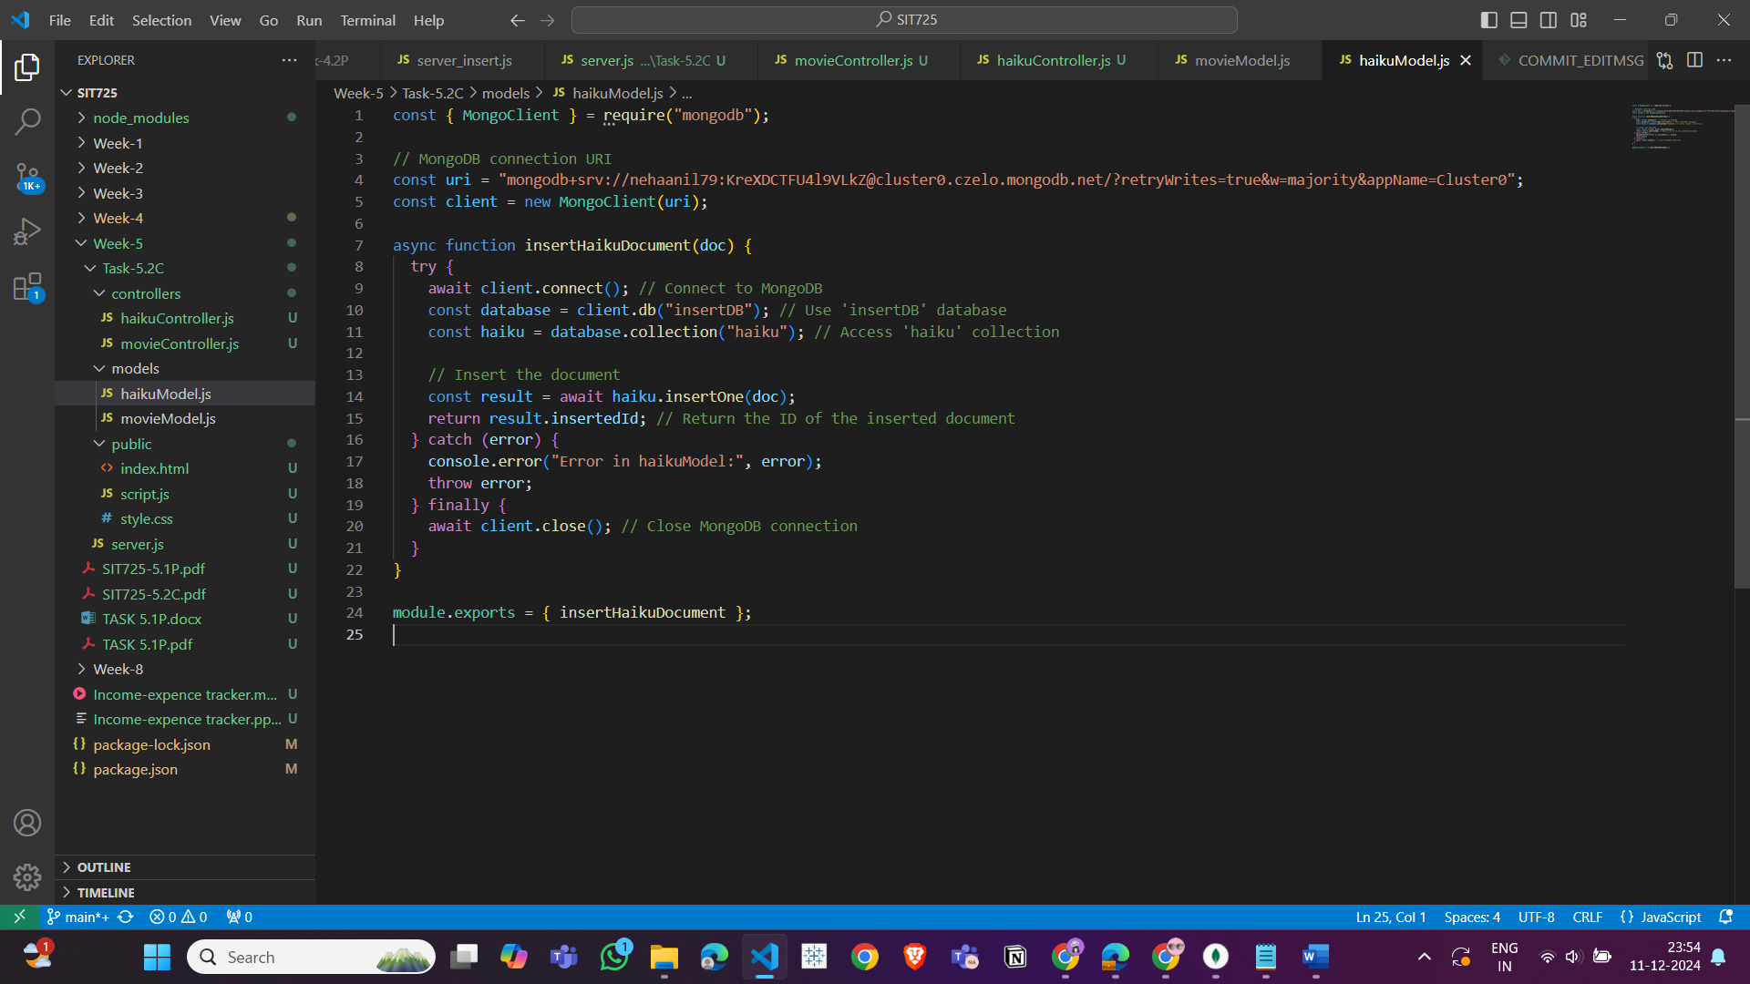

Code in **Controller** folder:

Server.js

My repo link:

<https://github.com/nehaanil12345/SIT725.git>